**APICULTURE**

Apiculture is the scientific method of rearing honeybees.

**Introduction**

Beekeeping emerged as an economical and profitable culture in 19th century due to implementation of advance and scientific approaches and generally practiced in places like forest areas, hills and agricultural lands, etc. Movable frame hives were constructed initially in 1880 A.D. and practiced for keeping Bees.

**Advantages of apiculture-**

* Provides honey, which is the most valuable nutritional food.
* Provides bee wax, which is used in many industries,

including cosmetics industries, polishing industries,

pharmaceutical industries, etc.

* Plays an excellent role in pollination.

**Disadvantages of apiculture-**

* Non-Natives: While we manage honeybees for
* honey &amp; pollination, there is some concern that
* honeybees are outcompeting our native bees in
* the wild. Honeybees are non-natives.
* Stings can happen with honeybees.
* Cost of supplies.
* Bee diseases.

**Downfall of Beekeeping/Apiculture-**

Within last decades of 21st century, it has been observed that honeybee colonies are decreased continuously due to reduction in apicultural activities which draw the more intension of scientific research to enhance the beekeeping practices.

**The rise of Apiculture/Beekeeping-**

There is a common phrase that appears in the popular

press, in grant proposals and as a fund-raising theme for several environmental groups: “The decline of the honeybee.” This is often referenced as a looming threat to the future of our food supply and typically blamed on pesticides. In fact, honeybees in the US are doing quite well in terms of hive numbers and availability to pollinate crops. The same is true in other regions.

The truth is that the number of colonies of bees are certainly not declining and have actually increasing in recent years.

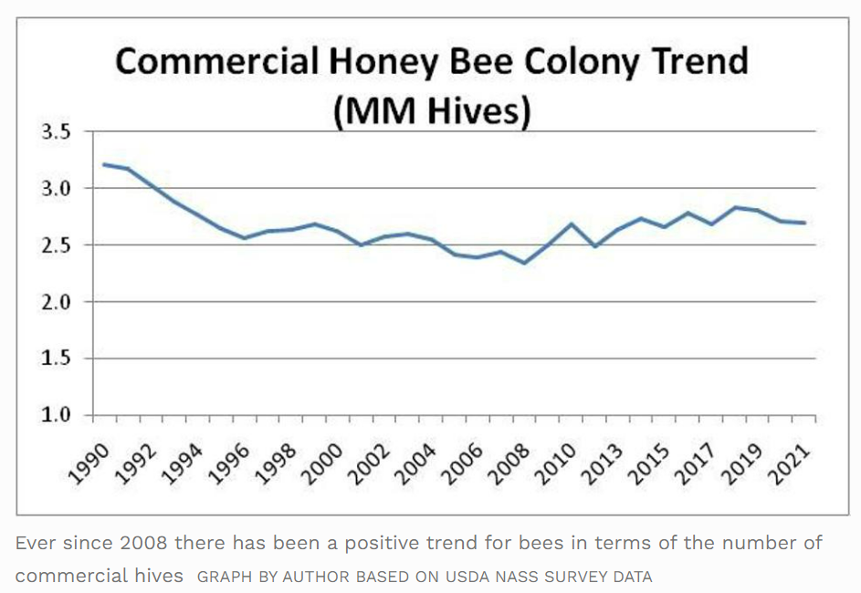

**Types of honeybees-**

There are 3 kinds of honeybees:

1. Queen

2. Drones

3. Workers

1. Queen:

* A queen bee is typically an adult, mated female (gyne) that lives in a
* colony or hive of honeybees. With fully developed reproductive organs, the queen

is usually the mother of most, if not all, of the bees in the beehive.

* Queens are developed from larvae selected by worker bees and specially fed in order

to become sexually mature. There is normally only one adult, mated queen in a hive,

in which case the bees will usually follow and fiercely protect her.

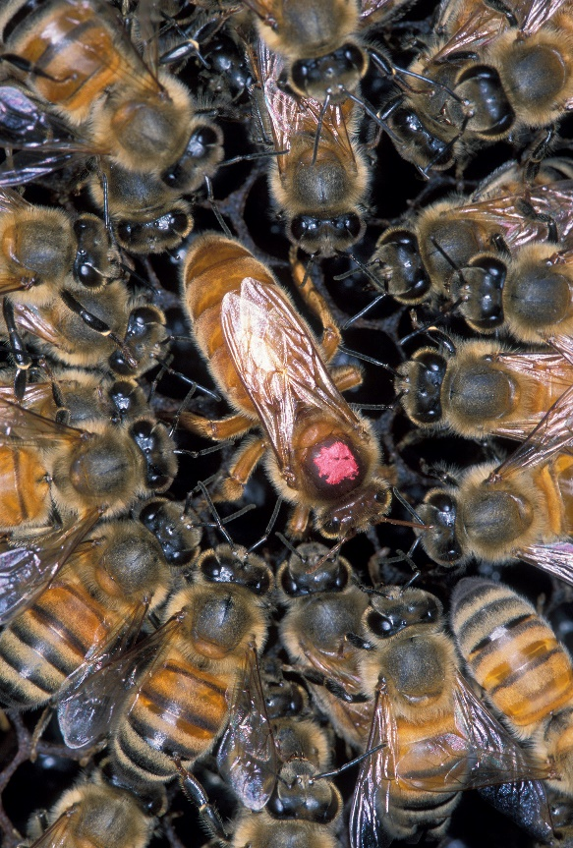

2. Drones:

* A drone is a male honeybee. Unlike the female worker bee, drones do not

have stingers. They gather neither nectar nor pollen and are unable to feed

without assistance from worker bees. A drone&#39;s only role is to mate with a

maiden queen in nuptial flight.

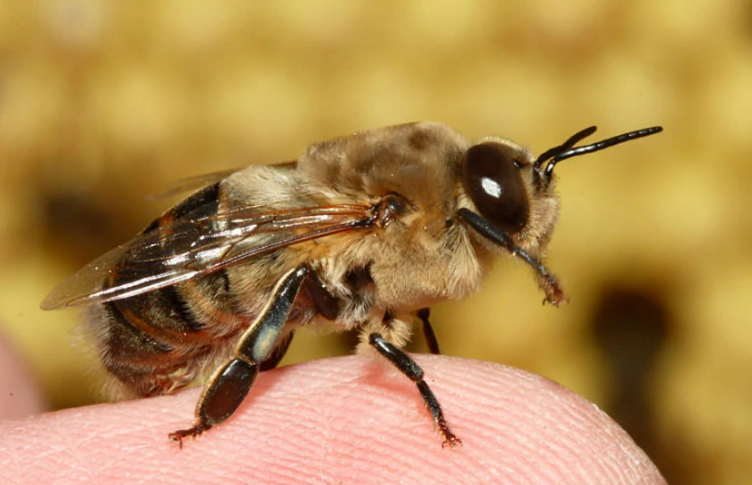

3. Worker:

* A worker bee is any female (eusocial) bee that lacks the full reproductive

capacity of the colony&#39; s queen bee; under most circumstances, this is

correlated to an increase in certain non-reproductive activities relative to a

queen.

* While worker bees occur in all eusocial bee species, the term is rarely used

(Outside of scientific literature) for any bees other than honey bees.

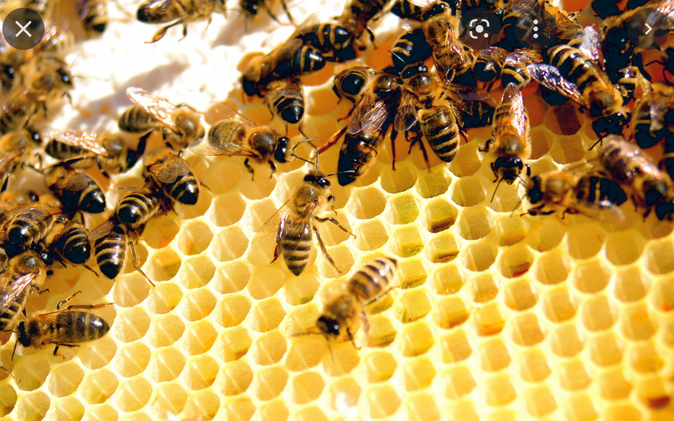

Life cycle of honeybees –

The life cycle of honeybees is divided into four stages:

* Egg
* Larval
* Pupal
* Adult Stage

**Hive Pest Management**

Pest control in and around your beehives is important to the survival of your

colony. Manage mites and parasites with the appropriate pest control treatments,

and block bears, skunks, and other animals from raiding your hives with electric

fencing and supplies.

Varroa mites are a serious threat to hives — they kill honeybees, weaken colonies,

and spread deadly viruses throughout the hive. The combination of varroa mite

infestation and virus infection results in a deadly condition called Parasitic Mite

Syndrome (PMS). In order to keep bees safe, you must monitor the hive to keep

the number of mites low. In general, if mite levels rise above 3 to 4 percent, the

colony needs treatment.

Proper management of this hive pest is crucial to the health of your bees — and we

cannot stress it enough. We believe that if you do not monitor for varroa mites, and

treat, when necessary, you will cause harm to your bees and reduce their chance of

survival.

**Beehive Pest Management and Medications**

Beehive pest management and medication application are important issues to know

about as a beekeeper. We recommend regular sugar shakes or 24 hours drop

Varroa tests to keep track of your mite levels. Avoid putting undue stress on your

bees and use pest control treatments in your hive only when necessary.

In addition to Varroa mite treatments like Formic Pro, we carry products to treat,

prevent, or test for Wax Moth, American and European Foulbrood, Nosema, Small

Hive Beetle, and mice. Use these pest tests and treatments to keep your hive

healthy and productive.

As beekeepers now need permission from a veterinarian to administer antibiotics to

treat American Foulbrood, we stopped selling these antibiotics January 1, 2017.

Dr. Chris Cripps, Better bee part-owner, beekeeper, and veterinarian is part of the

effort to educate veterinarians about honeybee health and antibiotic use

**Cost Analysis of Apiculture**

A well-structured questionnaire supplemented with an interview schedule was used

to elicit information from the beekeepers. Benefit-cost analysis was applied as an

appropriate tool to evaluate the apiculture enterprises by Devonta (2006).The cost

and benefit sides were separately computed, and the cost side divided the benefit

side to compute the B-C ratio. The cost items were grouped into two categories,

i.e., i) fixed costs and ii) variable costs. To find out the total cost (TC), total fixed

cost (TFC) was added to total variable cost (TVC). Likewise, average cost (AC)

was obtained by adding average fixed cost (AFC) and average variable cost (AVC)

as

TC = TVC + TFC, and AC = ATC + AVC.

Where, AC = TC/No. of colonies.

On the benefit side, all the benefit items were studied, and evaluation of apiculture

industry was made. The benefit-cost ratio was computed by using the formula

B/C = TR/TC

Bee farming is an important seasonal activity that has predominantly remained

rudimentary and unexploited, yet it has tremendous potential for widening the

country’s export base. As, in many societies, honey is regarded as an important

ingredient in diet and is also used as medicine (chemotherapy). Honey and other

hive products are demanded for their many useful properties and applications in a

wide range of Industries, keeping in view the importance of this unexploited field,

the present study is an effort to examine the benefit-cost analysis of beekeeping.

**Subsidies on Beekeeping**

Those who do not fulfill the educational qualification may get Rs. 10 lakhs to start

beekeeping as a full-time business venture under the Prime Minister Employment

Scheme. The government will provide a 35 percent subsidy and the reserved

category applicants will be required to invest 5 percent from their own pockets.

Animal husbandry is a business where the possibility of loss is very less. Along

with farming, animal husbandry has also been continuously promoted in all the

states of the country. For this, the central and state governments are running many

schemes. In this series, the Haryana government has increased subsidy on

beekeeping to promote animal husbandry across the state.

**Increased subsidy on beekeeping**

Subsidy on beekeeping in Haryana has been increased by 45 percent. Earlier, up to

40 percent subsidy was given on bee keeping, but now 85 percent subsidy will be

given with an increase of 45 percent. According to reports, horticulture department

of the state will soon publicize the subsidy amount including beekeeping and

promotion. Under this, farmers, planters and unemployed youth will be motivated

to adopt the business of beekeeping.

**How to get Subsidy for Beekeeping?**

According to the Horticulture Department, farmers, gardeners and unemployed

youth can directly contact the Horticulture Officers or Deputy Directors of

Integrated Beekeeping Development Center Rajnagar, Kurukshetra to avail the

increased subsidy amount in government schemes. After this, you can apply and

take advantage of the schemes.

Why do beekeepers use smoke?

Have you ever seen a beekeeper use a metal contraption to blow smoke

before opening the hive? This device is called a smoker, and it’s an

essential tool that keeps bees and beekeepers safe.

We’re often asked, “How do beekeepers avoid getting stung?” In short, it’s

by smoking their hives.

Beekeepers use smoke to keep bees calm during hive inspections. When

bees sense danger, they release an alarm pheromone called isopentyl

acetate from a gland near their stingers. This chemical wafts through the air

and alerts other bees to be ready to attack. Smoking a beehive mask this

pheromone, allowing the beekeeper to safely perform a hive inspection.

**What is a bee smoker?**

A bee smoker is the device beekeepers use to puff smoke into their hives.

This smoke doesn’t harm bees, it just interferes with their sense of smell so

that they don’t react to alarm pheromones. Bee smokers are usually

referred to as “smokers” for short.

A smoker consists of three main parts: the bellow, nozzle, and fire

chamber. The bellow attached to the fire chamber allows you to restrict the

flow of oxygen. This means you can keep your smoker lit for a long time

and control the smoke. Just squeeze the bellow to get a puff of smoke from

the nozzle.

It’s hard to believe there was ever a time where beekeepers worked without

smokers! But it wasn’t until 1873 that Moses Quimby, the father of American

beekeeping, first invented the smoker

**Apiculture’s Role in Poverty Alleviation**

* When apiculture forms part of people’s livelihood strategies there are various possible outcomes. Some of these outcomes will include income and material goods, but also non-material outcomes such as well-being and contentment.
* In terms of apiculture, the least visible livelihood outcome is the pollination of flowering plants, both wild and cultivated: this is an outcome impossible to quantify.
* Honey is a traditional medicine or food in nearly all societies and whether sold in a simple way at village level or packaged more sophisticatedly, honey generates income and can create livelihoods for several sectors within a society.
* Beeswax is also a valuable product from beekeeping, although in some places its value is not appreciated.
* Industrialized countries are net importers of beeswax, and the supply comes from developing countries.
* The beekeepers and other people in a community can create further assets by using honey and beeswax to make secondary products, such as candles, beauty creams or beer.
* Selling a secondary product brings a far better return for the producer than selling the raw commodity.
* Bees also generate other products (pollen, propolis and royal jelly) that can in some situations be harvested, marketed and made into secondary products: all of this work effectively strengthening people’s livelihoods.

**Modern Techniques of Bee Hiving:**

**1. Hive Tracks**

Good beekeepers keep good records, and modern beekeeping technology makes collecting info more efficient. hive Tracks offers a digital alternative to monitoring changes in your hives. Both commercial beekeepers and hobbyists can use this cloud-based software to record hive conditions, such as population, temperament, brood pattern and honey stores. hive Tracks can also snap photos, map where your bees are foraging and remind you about important tasks, such as feedings and inspections. Plans start at $5 per month for five hives.

**2. Themo solar Hive**

This modern beekeeping technology protects against pests that might wipe out your colony, or otherwise require chemical treatments. The patented Thermo solar Hive has a rooftop solar panel that heats the hive’s interior to a temperature that bees can tolerate but dangerous Varroa mites cannot. The inventors say that the thermo-solar energy can also boost colony expansion and honey collection up to 75 percent. Prices start at $538.

**3. Bee Smart**

The [Bee Smart Pollinator Gardener](https://www.pollinator.org/bee-smart-app) app helps you select bee-friendly plants. Browse its plant database by light or soil requirements, bloom time, colour or which pollinators they attract. While it was originally designed to help gardeners, beekeepers can use the free app to provide more forage for their colonies.

**4. Buzz Box**

This smart bee management system can help you track everything from afar. The [buzz Box Mini](https://www.osbeehives.com/products/buzzbox-mini) hive health monitor — a small sensor that attaches to the side of your beehive — monitors sounds inside the hives. It uses artificial intelligence to detect issues like missing queens, swarming and parasites. The sensor also monitors temperature, humidity and barometric pressure around the beehive. Receive alerts via a smartphone app if something is amiss. buzz Box costs $199.

**5. Flow Hive**

The 2015 crowdfunding campaign for the [Flow Hive](https://www.honeyflow.com/) raised more than $13.2 million, making it one of the most successful campaigns in crowdfunding history. It allows beekeepers to harvest honey by turning a lever to start the flow, which means no more opening the hive to extract each frame and disturb your bees. A second-generation design, Flow Hive 2, includes small design tweaks such as a harvesting shelf to hold honey jars. Prices start at $499.

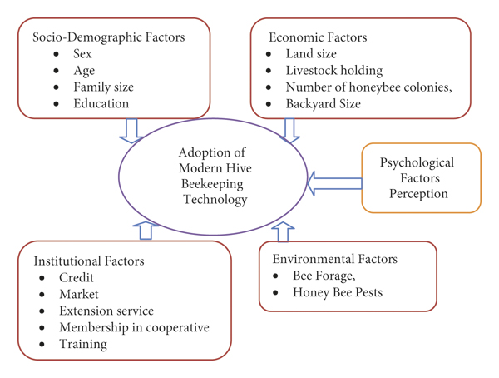

# **Important Tools used in Beekeeping**

Why tools are required for beekeeping

Beekeeping tools are required to efficiently collect the honey. A **bee sting** is a wound and pain caused by the stinger of a female bee puncturing skin.

In this session, we will discuss some important tools listed below to help us understand how to use them.

* Smoker
* Mesh Helmet
* Electric Uncapping Knife
* Hive Stand
* Bee brush
* Sting Resistant Gloves

Smoker

A **bee smoker** (usually simply called a **smoker** or a smoke pot) is a device used in beekeeping to calm honeybees. It is designed to generate smoke from the smoldering of various fuels, hence the name.

It is commonly designed as a stainless-steel cylinder with a lid that narrows to a gap with a half-inch diameter. The base of the cylinder has another small opening that is adjacent to a bellow nozzle. Pumping of the bellows forces air through the bottom opening. The cylinder also commonly has a wire frame around it acting as a structure the user can grab without the risk of burning their hand. Some smokers have a hook on the side allowing the user to hang the whole instrument on the side of a hive for easy access during an inspection or attach it to an ALICE belt when not in use.

**Why do beekeepers use smoke?**

Beekeepers use smoke to keep bees calm during hive inspections. When bees sense danger, they release an alarm pheromone called ***isopentyl acetate*** from a gland near their stingers. This chemical wafts through the air and alerts other bees to be ready to attack. Smoking beehive masks this pheromone, allowing the beekeeper to safely perform a hive inspection.

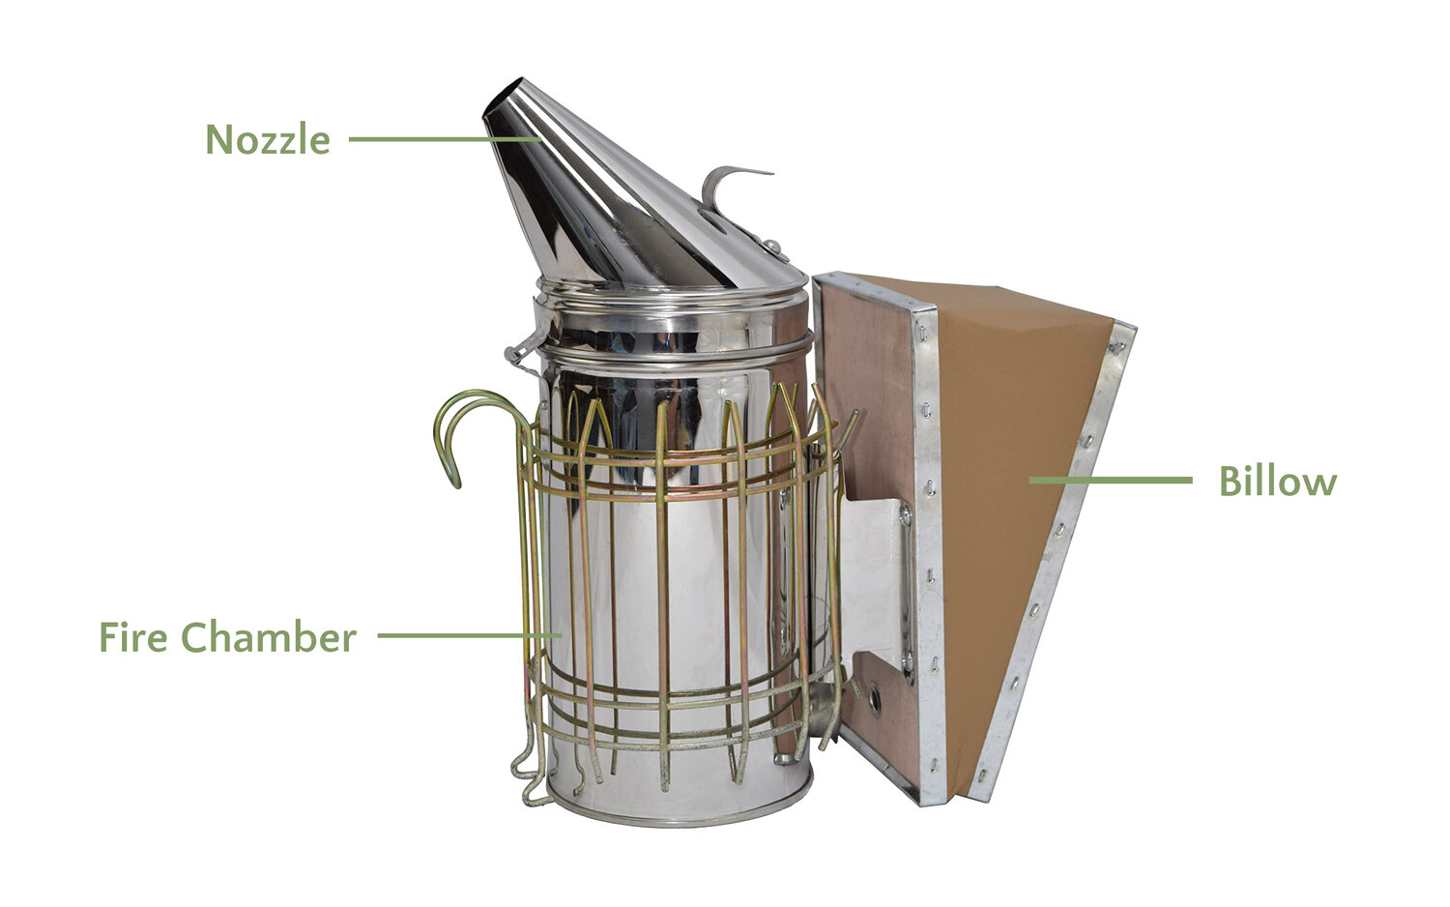**What is a bee smoker**?

A bee smoker is the device beekeepers use to puff smoke into their hives. This smoke doesn’t harm bees, it just interferes with their sense of smell so that they don’t react to alarm pheromones. Bee smokers are usually referred to as “smokers” for short. A smoker consists of three main parts: the bellow, nozzle, and fire chamber. The bellow attached to the fire chamber allows you to restrict the flow of oxygen. This means you can keep your smoker lit for a long time and control the smoke. Just squeeze the bellow to get a puff of smoke from the nozzle.

It’s hard to believe there was ever a time when beekeepers worked without smokers! But it wasn’t until 1873 that Moses Quinby, the father of American beekeeping, first invented the smoker.

**What does smoke do to bees?**

Smoke causes bees to prepare to leave their hive because they believe it is on fire. They begin to eat lots of honey, thinking they need the energy to go find a new home. Engorged with honey, their abdomens are so full it makes it hard for them to sting. (Imagine the feeling of bending down to tie your shoe after a big dinner.)

As long as the smoke is not too hot, it does not harm bees. I always puff some smoke onto my arm to make sure it’s cool to the touch.

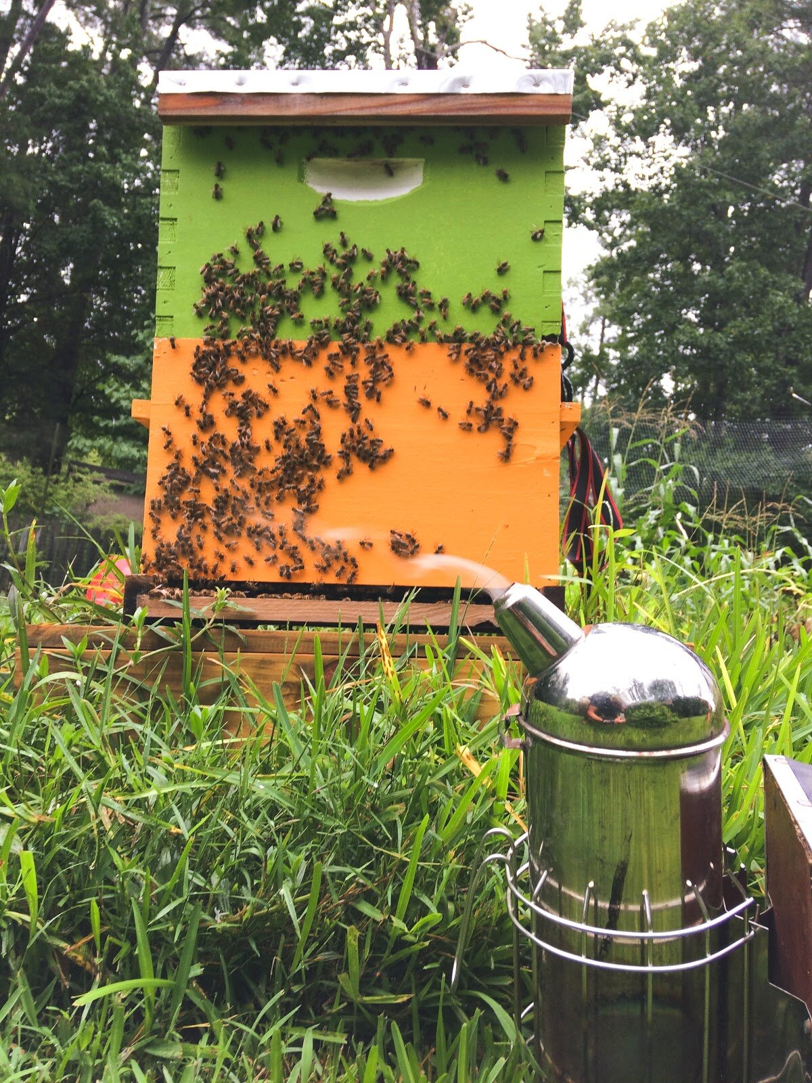

Beekeepers inspect their hives to ensure they’re healthy. The goal is never to harm the colony.

Imagine trying to talk to your friends over the sound of loud music. This is similar to the experience a colony has when a beekeeper smokes the hive. The bees' sense of smell is disrupted by the smoke, so they can’t communicante

**What the smoke beekeepers use?**

The smoke beekeepers use can come from a variety of fuels such as burlap, pine needles, wood pellets, twigs, or cardboard. The role of smoke is to calm bees; therefore, you should never use synthetic materials or paper that’s been bleached as it can irritate the bees.

Good smoker fuel burns slowly, lights quickly, and most importantly, produces smoke. Strong chemical smells can be harmful to bees. If you like your smoker and get an acrid smell, find a new fuel.

Many shops sell smoker fuel, but it’s easy to find for free at home.

I’m lucky enough to have a yard waste collection service in my neighborhood. This means every so often, I can just go into my neighbor’s trash and collect buckets full of pine needles—the perfect fuel for a smoker.

A good beekeeper always has a store of smoker fuel at the ready. There are few things less frustrating than needing to rummage around the garden for fuel before opening the hive.

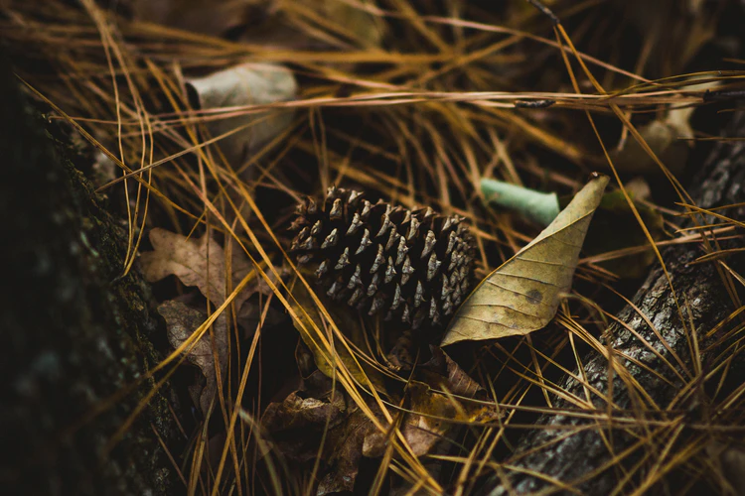

**Tips for how to smoke your hive:**

The best inspection is one where you and the bees feel safe. Stings can kill bees and sure aren’t fun for humans! That’s what makes smokers so important. Here’s how to use one

properly:

* Pack plenty of fuel into the smoker. You don’t want it to go out in the middle of an inspection.
* Puff a bit of smoke at the entrance of the hive prior to opening the cover. Think of this as letting your bees know, “Hey, I’m coming in!”
* Smoke isn’t a substitute for being gentle, calm, and smart. Be mindful when inspecting bees and only work the hive on days with good weather.
* Don’t use too much smoke. Unless you’re working with a particularly aggressive colony, a few puffs are all it takes.
* If you get stung, smoke the area. Once a bee stings, you can be certain others will get upset and begin to sting too. This is where smoke helps.

Mesh Helmet

**Mesh Helmet** is used for covering the human head and neck to protect the entire face before performing any activity with the beehive. Veils made with wire can protect the face and other portion of the body that has been covered with clothes. A light color should be used because it is observed that bees attack dark-colored clothes.

**Why do beekeepers use mesh helmets?**

The wide brim of our beekeeping hats provides support by keeping the veil away from the beekeeper's face and neck while the veil is in use. The hat also provides extra protection to the top of your head while keeping it nice and ventilated.

We have plastic and woven mesh safari-style helmets in both white and tan.

Beekeeping helmets protect your head from bees and can give extra stability for Tulle veils, square veils, and other veils without hat components to them.

Square Veils are metal mesh with defined sides to them making them easy to store away by simply folding them closed.

Tulie Veils have a plastic mesh that is lighter and stow away small enough to put in your pocket making them really great as a spare veil for someone visiting or for someone who wants a veil with the convenience of being able to drink water through it.

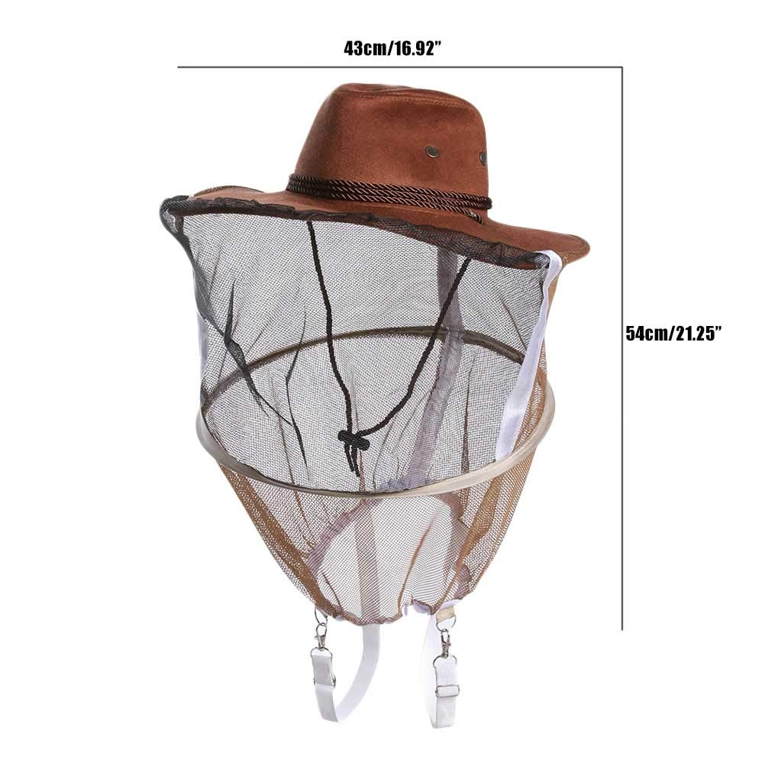

Mesh helmet

Excelsior Veils are round veils with less setup time since they usually are kept in an

unfolded state.

ImageIt’s important to keep things safe for yourself and your bees, using the proper gear like a helmet and veil can make a huge difference when it comes to effectively managing a beehive and not getting stung. Make sure to grab a veil with your helmet for full face coverage as well!

To clean the helmets just remove it from the veil, wipe out the inside and out with a wet rag sooner rather than later and let it air dry before placing the veil back on.

Electric Uncapping Knife

The Little Giant electric uncapping knife easily heats up and quickly removes the wax from frames of capped honey. Preset at the appropriate temperature for removal of caps, the heated knife heats up quickly and is ready to use within a minute.

**Why do beekeepers use Electric Uncapping knives**?

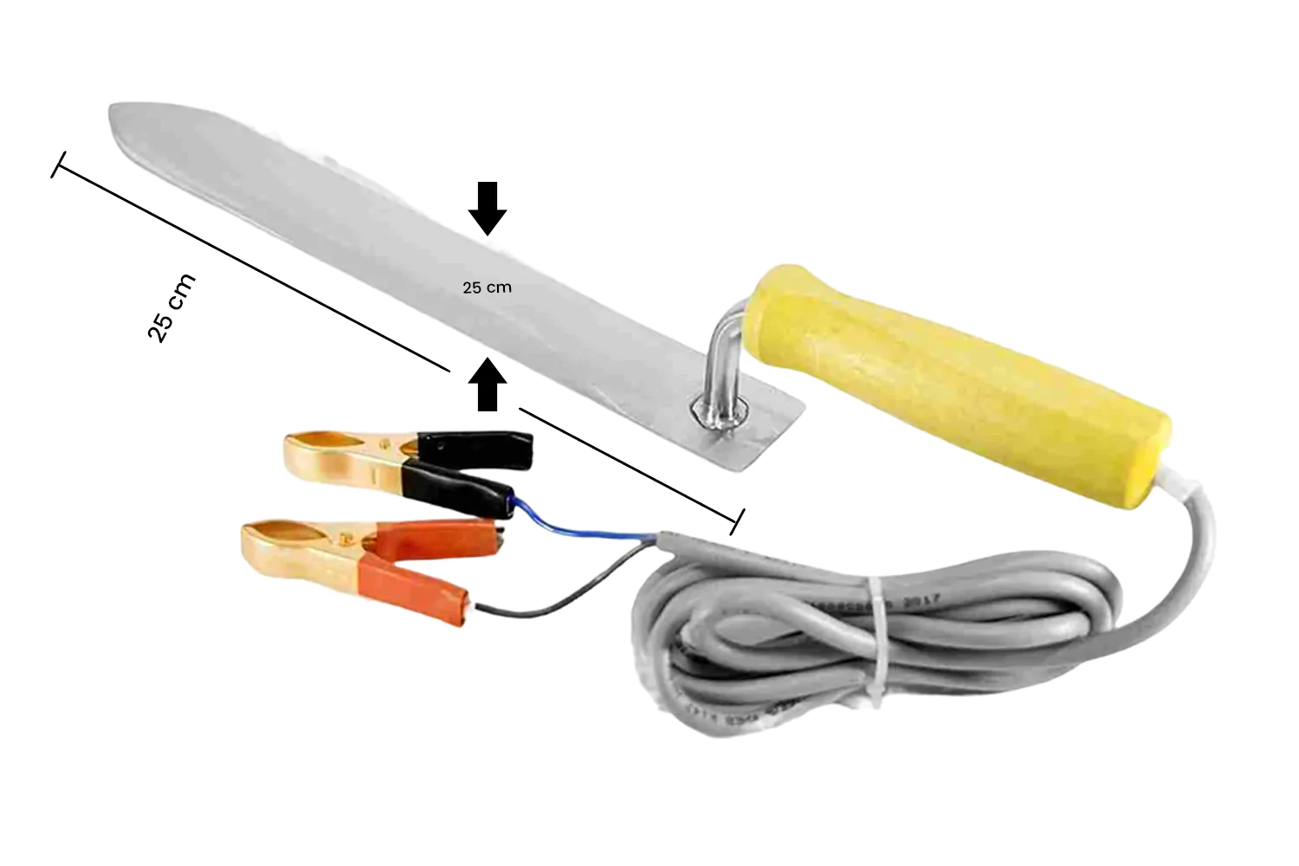

* An electric uncapping knife easily heats up and quickly removes wax from frames of capped honey.
* Preset at the appropriate temperature for removal of caps.
* Heats up quickly and is ready to use within a minute.

**Tips for how to Electric Uncapping Knife your hive**

* To use, simply plug into a power strip and allow the knife to warm up for a few minutes.
* Please exercise caution, the blade can become very hot and improper use can result in injury
* Built-in thermostat to prevent overheating
* Clean thoroughly after each use
* Need the ability to adjust temperature? Try our Speed King Electric Uncapping Knife with Control Unit

Image

Hive Stand

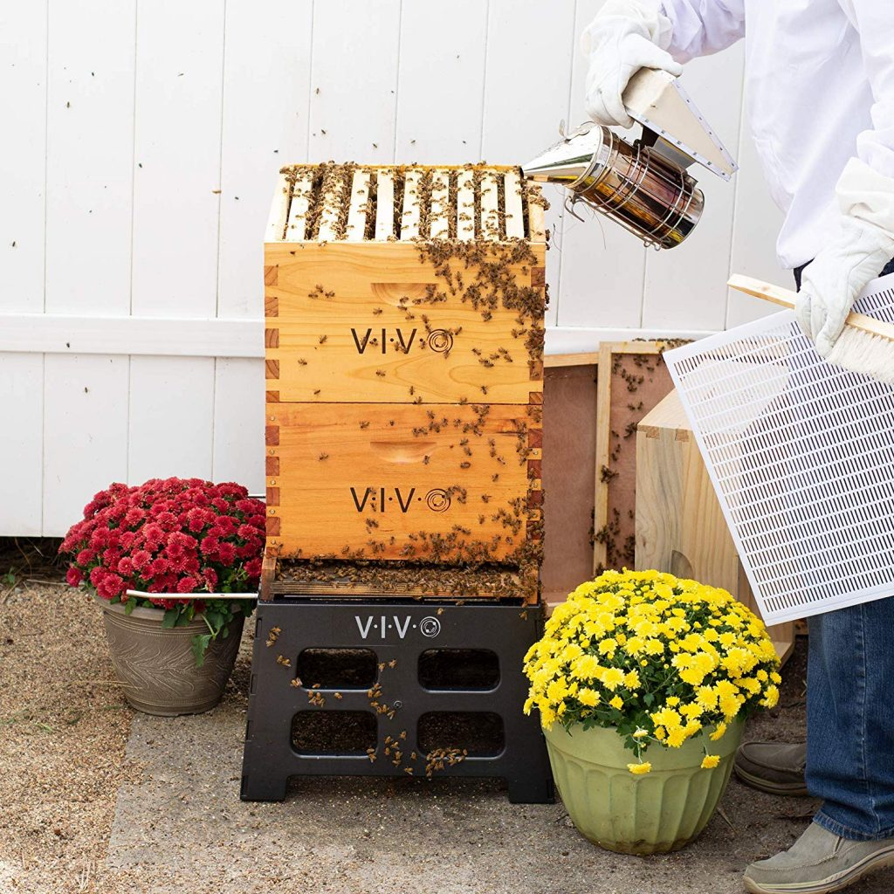In beekeeping, a ***beehive stand*** is a structure that elevates the beehive off the ground.  Hive stands are made of wood, plastic or metal and can be bought online, or if you are handy, you can make a beehive stand.    
A beehive stand can be used to hold a Langstroth or Warre hive and often has space for some beekeeping tools and frames. There are a variety of beehive stands for sale, with different features and at different price points.

**Benefits of Using a Beehive Stand**

There are many benefits too using a beehive stand. For the beekeeper, a hive stand makes it easier to work on the hive.  It is much more comfortable for a beekeeper to It is also beneficial for bees to have their hive elevated off the ground.  A hive stand keeps the hive off of the damp ground and away from ground moisture. This keeps the hive in better condition, reducing the risk of wood rot and mould.  

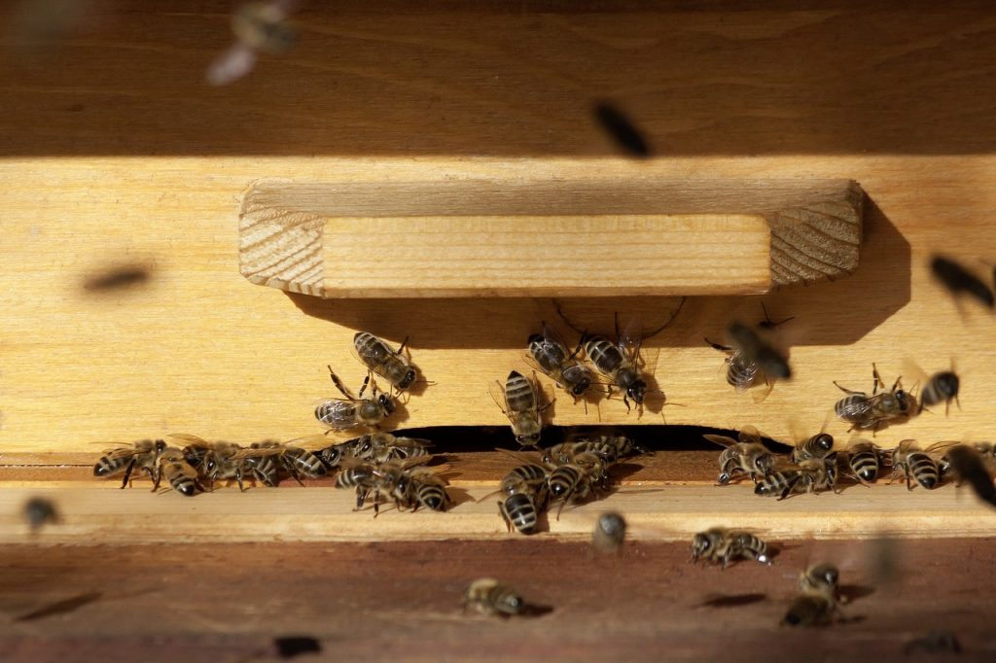Beehive stands are good for keeping predators and other pests, like ants away from the hive.  An elevated hive does help to deter ants it is best to also use a barrier coating on the legs of the stand. AntCant is a great non-toxic coating that prevents ants and other insects from crawling up to the hive.  It works by producing a surface where ants are unable to gain traction, so they cannot pass the barrier.

An elevated hive also makes it easier for the bees to get to their entrance.  A hive

placed on the ground could be surrounded by grass and weeds. You would have to clear the vegetation around your hive pretty frequently to ensure that the hive entrance is not concealed.  If you hive is on a stand the entrance would be more exposed and easier for the bees to enter.

Bee brush

A bee brush is***a soft-bristled brush that can be used to gently, and harmlessly, remove bees from a surface****.* The bee brush is best used in a small scale to move fewer bees per session, if the desired goal is to move bees quickly, in quantity the bee blower may be the proper tool.

**Why to use a bee brush**

Your bee brush is one of the most essential tools you can have during inspections and extraction time. The brush is used to ***gently brush honeybees off of your frames***so that you can inspect your frames more closely.

It is also commonly used to brush bees off of frames before removing the wax capping’s and placing the frame in an extractor.

ImageThe bristles on the bee brush are stiff enough to brush bees off the frames, but also soft enough not to damage or kill bees that may be difficult to get off the frames.

**ImageHow to use a bee brush**?

Using a gentle sweeping motion, the beekeeper uses a bee brush with long soft bristles to remove bees from the frames when collecting honey. Beekeepers are always careful not to hurt bees when removing them. Commercial beekeepers often use a bee blower (which is much like a leaf blower) for this job.

Sting Resistant Gloves

***Sting Resistant Gloves*** protect the hands from honeybee stings during the handling of beehives. Gloves should be made with flexible clothes or leather, which facilitates the easy movement of the hand and fingers.

**The Importance of Apiculture for Rural Livelihoods**

Beekeeping tends to be perceived as ‘a hobby’, or as ‘a sideline activity’. These descriptions may often be true, but a resilient livelihood – one that keeps people out of poverty – is one that has access to range of options. In this case, apiculture and related trades can be sources of valuable strength to countless numbers of rural people's livelihoods. Rather than just a ‘hobby’, beekeeping may be seen as an important occupation and part of rural life worldwide. In rural communities where access to income is limited, small- scale beekeeping can contribute significantly to livelihood security. Apiculture and related trades tends to be underplayed in both policy and planning. One reason may be the focus of rural development, wherein crop production and livestock rearing are taken to be dominant activities in rural areas. This perspective can render invisible the part beekeeping occupies in social life, culture, and local economies.

Beekeeping does not fit easily into the sectoral divides of rural development: as an activity, it spans forestry, horticulture, agriculture, the natural environment, animal husbandry and entomology without fitting precisely into any one of these sectors. Likewise, pollination is an important part of horticulture, yet the management of bees is often considered part of animal production. Similar problems confront the classification of bee products because honey is a food, yet beeswax is listed amongst non-food waxes and oils. Beekeepers have been categorized in different times and places as farmers, hunters and gatherers, cattle-keepers, or rural dwellers – with beekeeping remaining hidden as an important skill and part of their lives. These ambiguities present complications for development policymakers, practitioners and researchers, even though such complexity is in keeping with the way people themselves link different activities, resources and products together in their daily lives.

This very complexity explains the attraction of sustainable livelihoods approaches for securing a more visible position for beekeeping within rural development (Carney, 1998). Beekeeping fits well into the people-centered perspectives of sustainable livelihoods approaches. Such approaches have contributed towards moving rural development away from economic and resource-based interventions, towards people and their rights and obligations to the resources on which their livelihoods are based.

Beekeeping is a small-scale but very widespread activity. Unless you are aware of it, it is easy to visit villages and not see beekeeping. It does not attract much attention.

**Creating a Livelihood from Beekeeping**

According to the accepted definition originally developed by Chambers and Conway (1992): “A livelihood comprises the capabilities, assets and activities required for a means of living. A livelihood is sustainable when it can cope with, and recover from, stresses and shocks and maintain or enhance its capabilities and assets, both now and in the future, while not undermining the natural resource base.

Everybody’s livelihood depends upon access to many different types of assets. In order to make it possible to think about people’s differing livelihoods, and to allow analysis, all assets may be allocated into one of five fundamental categories: human, physical, financial, social and natural. To understand this well, think about your own livelihood and all the diverse assets it depends upon: your skills; access to transport; equipment; telecommunications; the social networks you have been born into or have created yourself. No single category of capital asset – for example finance – is on its own a sufficient basis for creating a livelihood.

Beekeeping is a useful means for strengthening and creating people’s livelihoods because it both uses and creates a range of different capital assets. Successful beekeeping can be achieved by drawing upon all of the five categories of capital asset shown above, although financial capital need not be essential for productive beekeeping. (Although of course financial capital assets may be essential for family and household well being, without which beekeeping may not be possible.) The five types of capital assets are a fundamental part of the framework used to explain the Sustainable Livelihoods Approach (see Figure 1 on page 20).

**Apiculture’s Role in Poverty Alleviation**

When apiculture forms part of people’s livelihood strategies there are various possible outcomes. Some of these outcomes will include income and material goods, but also non-material outcomes such as well-being and contentment. In terms of apiculture, the least visible livelihood outcome is the pollination of flowering plants, both wild and cultivated: this is an outcome impossible to quantify. Honey is a traditional medicine or food in nearly all societies and whether sold in a simple way at village level or packaged more sophisticatedly, honey generates income and can create livelihoods for several sectors within a society. Beeswax is also a valuable product from beekeeping, although in some places its value is not appreciated. Industrialized countries are net importers of beeswax, and the supply comes from developing countries. The beekeepers and other people in a community can create further assets by using honey and beeswax to make secondary products, such as candles, beauty creams or beer. Selling a secondary product brings a far better return for the producer than selling the raw commodity. Bees also generate other products (pollen, propolis and royal jelly) that can in some situations be harvested, marketed and made into secondary products: all of this work effectively strengthening people’s livelihoods.

Another crucial livelihood outcome is where, through strengthening people's livelihoods, beekeeping has managed to help a family become less vulnerable, strengthening their ability to look into the future, and reducing the chance that they will slip into poverty if a member of the family becomes ill or if a season is bad for farming or other activities.

In addition to their financial value, honey and beeswax have many cultural values and form part of ceremonies for birth, marriages, funerals, Christmas and other religious celebrations in many societies. Beekeepers are generally respected for their craft. All of these aspects are Livelihood Outcomes from the activity of beekeeping. While some may be difficult or impossible to quantify, they are real outcomes that strengthen people’s livelihoods and therefore should be acknowledged by a beekeeping intervention.